Install the tinygps plus library and run the code:

output will be:

Latitude in Decimal Degrees : 12.945850

Latitude in Degrees Minutes Seconds : 12 56 45

Longitude in Decimal Degrees : 79.167221

Longitude in Degrees Minutes Seconds : 79 10 1

Altitude : 219.600006

Time : 10/38/39

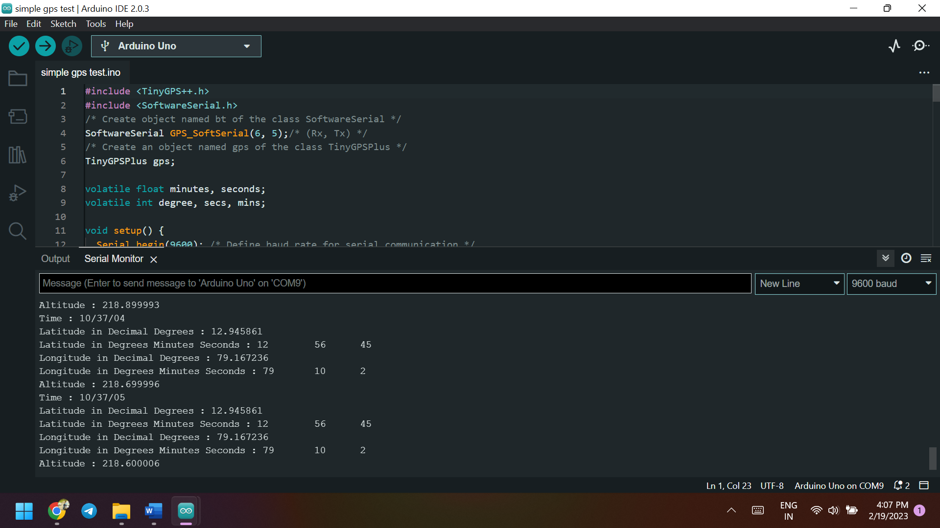

Reference:

https://www.electronicwings.com/arduino/gps-module-interfacing-with-arduino-uno